Negatives

# Heuristic: Recognition rather than recall

# Severity: 2

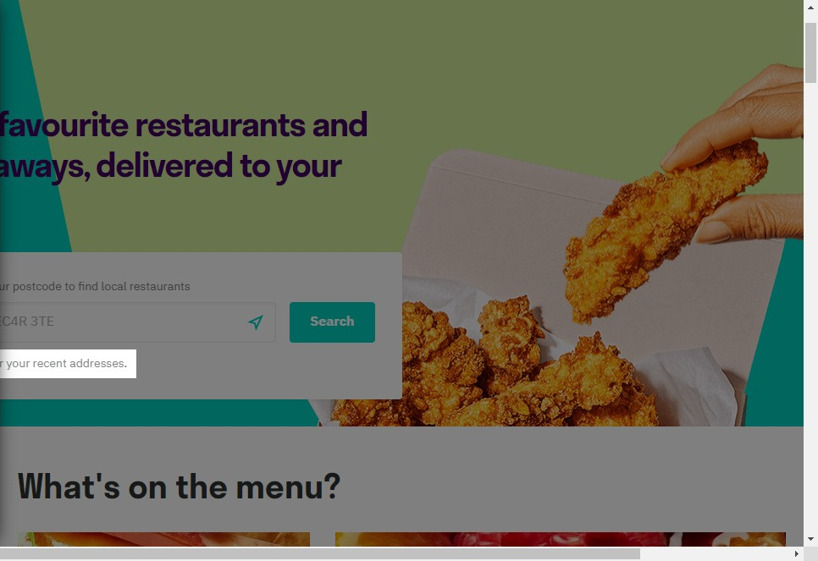

# Notes:

You have the sign in for 'recent address's' to be shown.

# Recommendation:

I don't think you should have to log in before you search. Especially if you want to do a quick search

# Heuristic: Match between system and the real world

# Severity: 0

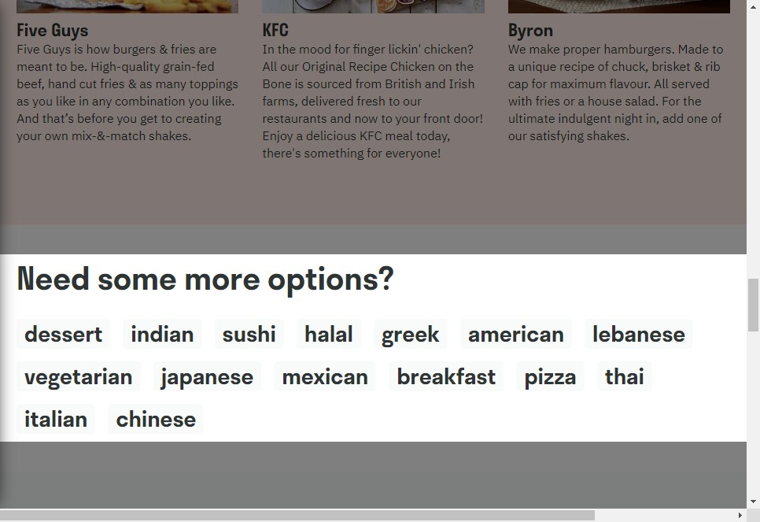

# Notes:

They have great selection of food options although they have only listed vegetarian and not just vegan too. There is always some confusion around this as some people really dont know the difference.

# Heuristic: Visibility of system status

# Severity: 2



# Notes:

This is only shown once a user is logged in , perhaps to entice the user to join this should be shown as you enter landing page